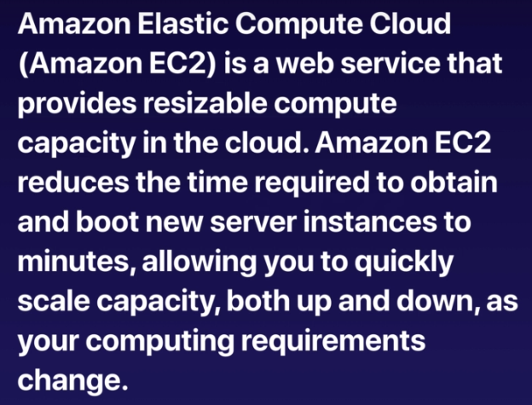

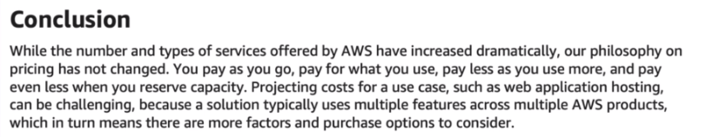

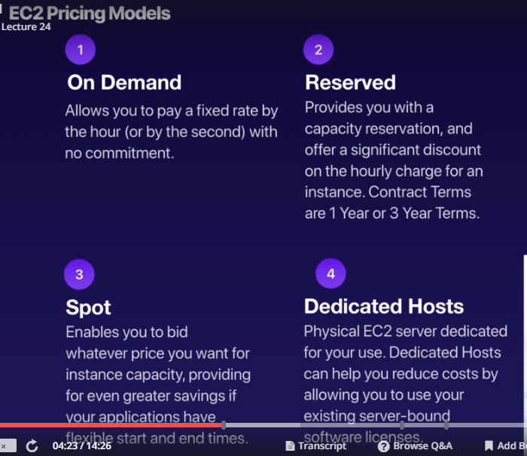

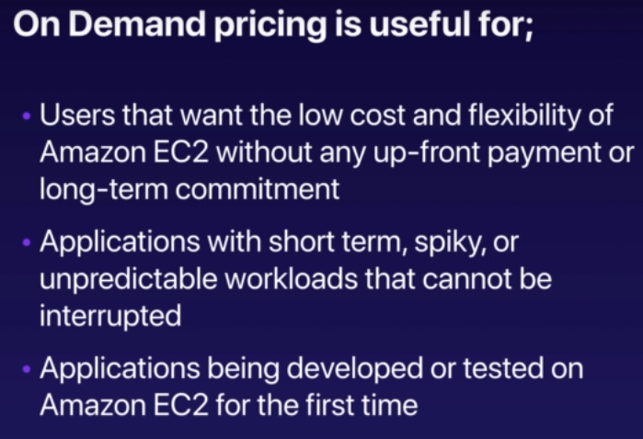

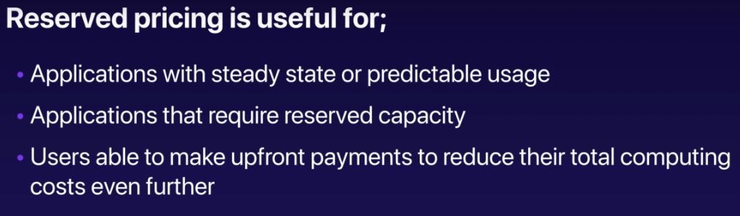

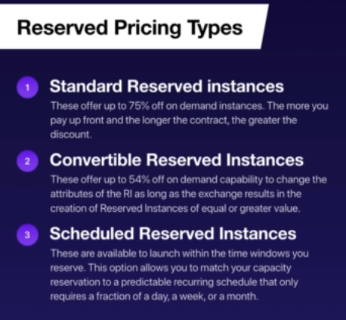

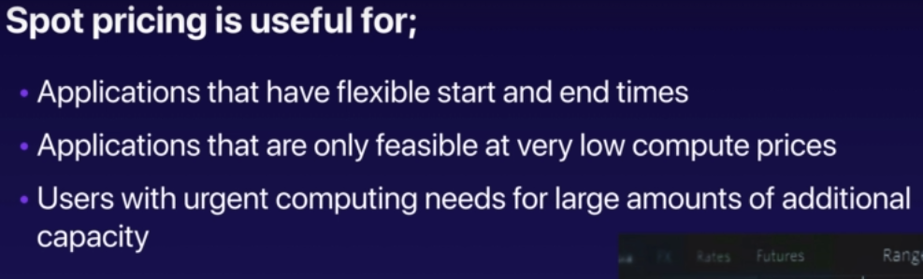

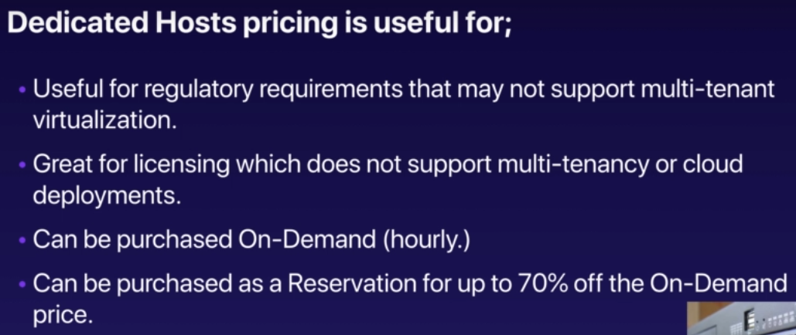

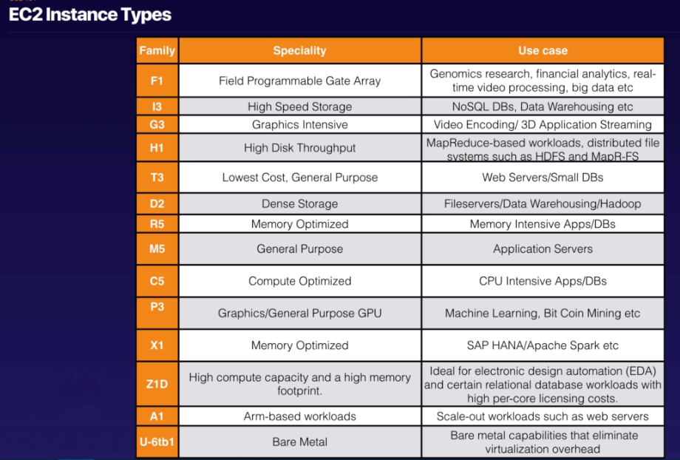

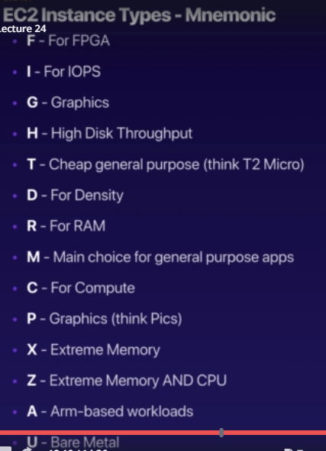

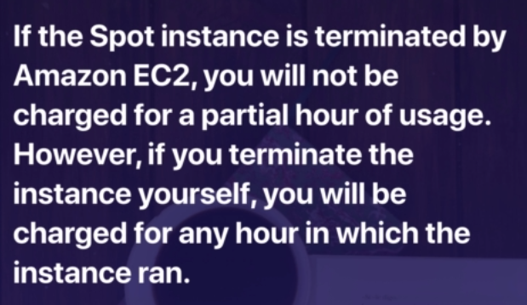

Important question above one

While launching instance, chose protect against accidental termination.

Providing additional tags like name of the server, department, who created would help us track the instance later on.

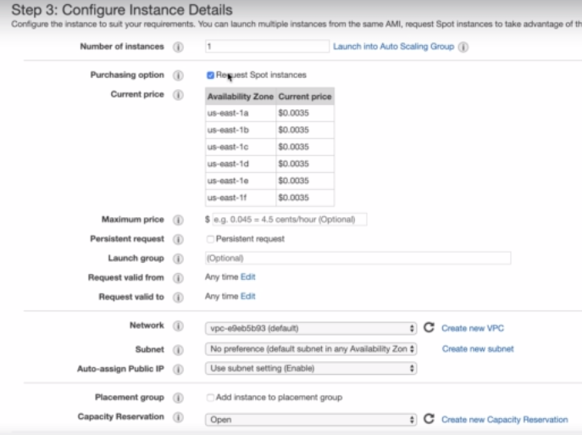

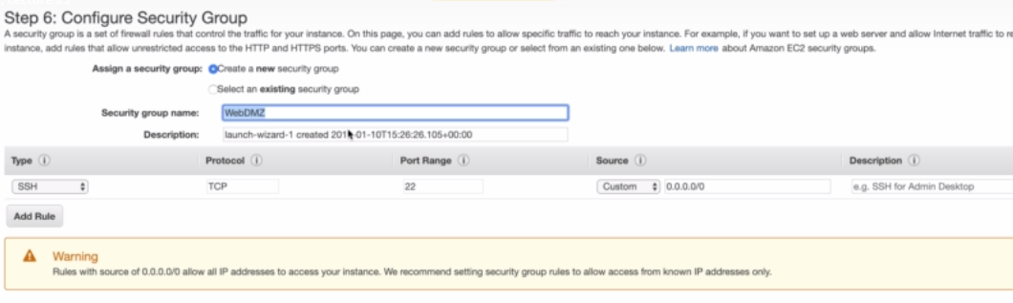

After login to instance yum update -y to update os based updates.

To install apache web server, use

Yum install httpd -y

Cd /var/www/html and create index.html here

Service httpd start => starts the server

Chkconfig on => will ensure if machine reboots this would start automatically

The **Chkconfig** command tool allows to configure services start and stop automatically in the **/etc/rd.d/init.d** scripts through command line.

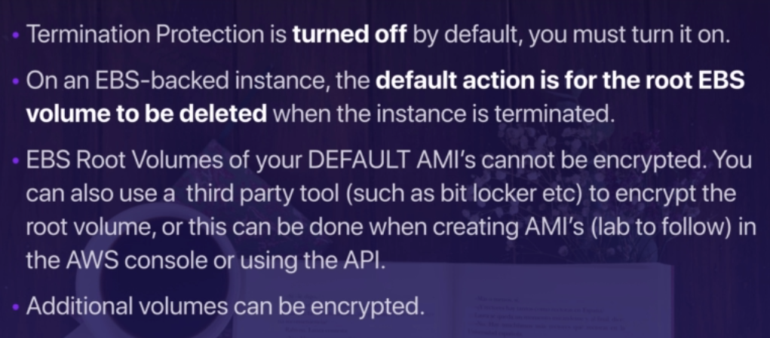

The information about instance can be obtained as below

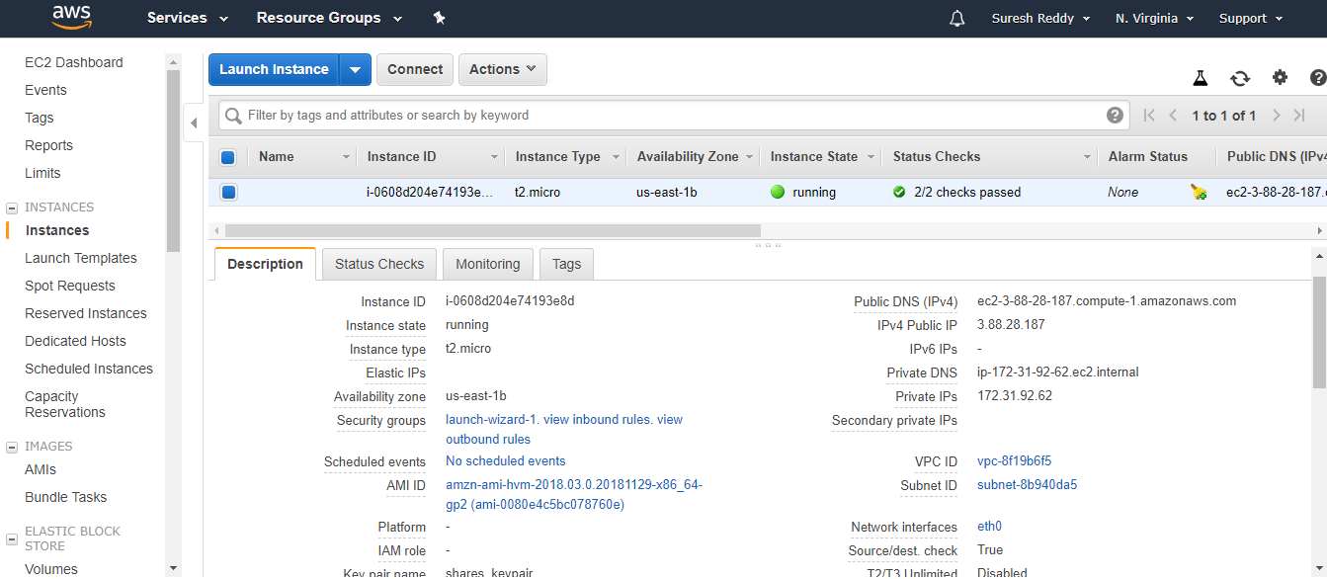

Monitoring tab shows various graphs depicting cpu and memory usage etc

Tags section shows tags associated with this instance.

Security groups:

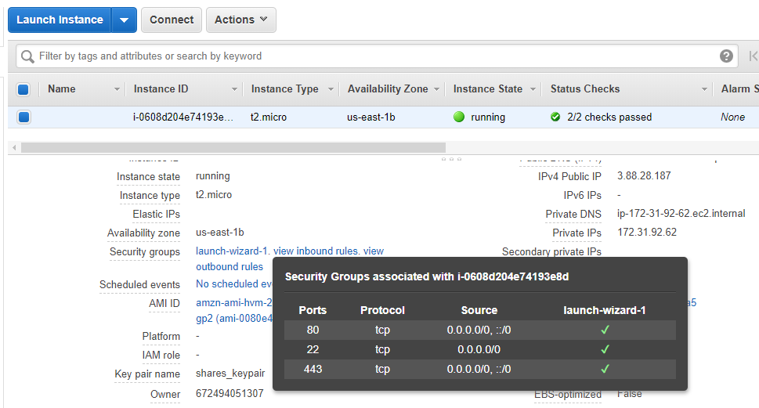

::/0 is for IPV6 addresses. 0.0.0.0/0 is for IPV4 addresses.

Any security group change is immediately effective. This is exam question

Security groups are stateful. So, when we create inbound rule to allow por 80 or 8080, it automatically allows outbound as well.

Network Access control Lists are stateless. So, we have to explicitly mention inbound and outbound rules separately.

We can assign more than one security group to an EC instance.

Actions -> Networking -> Change security groups

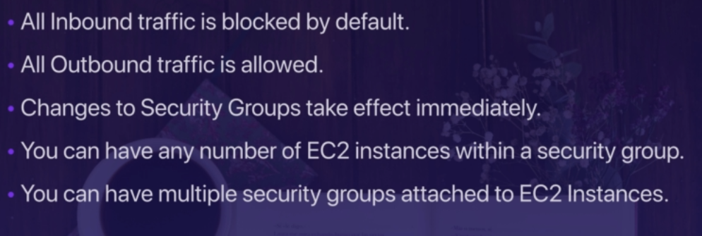

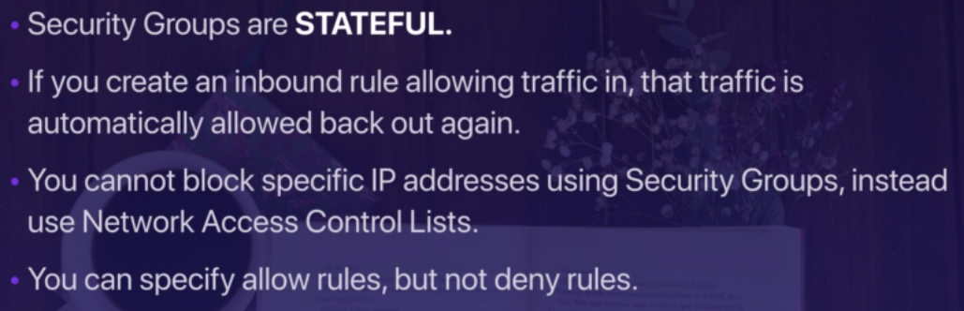

By default everything is denied. We should allow with explicit rules.

If we want to specific deny rules, it is only possible with NACL

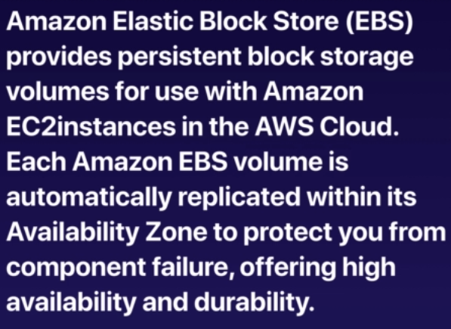

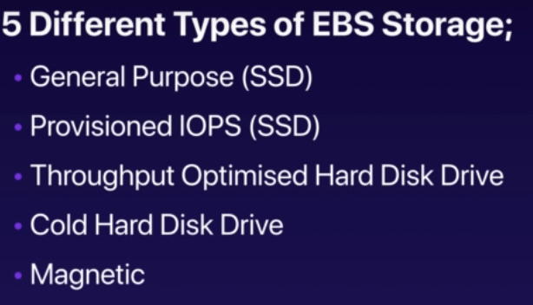

IOPs: Input output processing speed

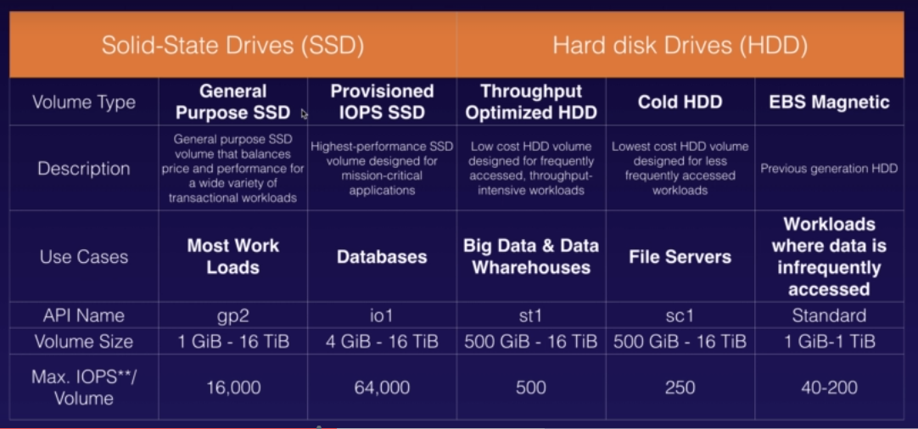

API names are important for exam.

The EC2 instance and EBS volume will be in the same AZ. We can verify this by going to menu options of EC2 and EBS. Important question.

When we terminate EC2 instance, the EBS volume also gets deleted automatically.

We can add additional volumes to EC2 instance and also we can move from one type to another.

We can take a snapshot of existing volume, create an image out of it. And then launch new EC2 instances out of it. This way we can create a copy of existing data to another.

We can also copy image to another region and then launch instances in that region. This is a popular exam question. This needs to be tested. This helps in migrating data to different machine easily.

When we delete EC2 instance, the root volume gets deleted but all other volumes will remain intact. This is also important exam question.

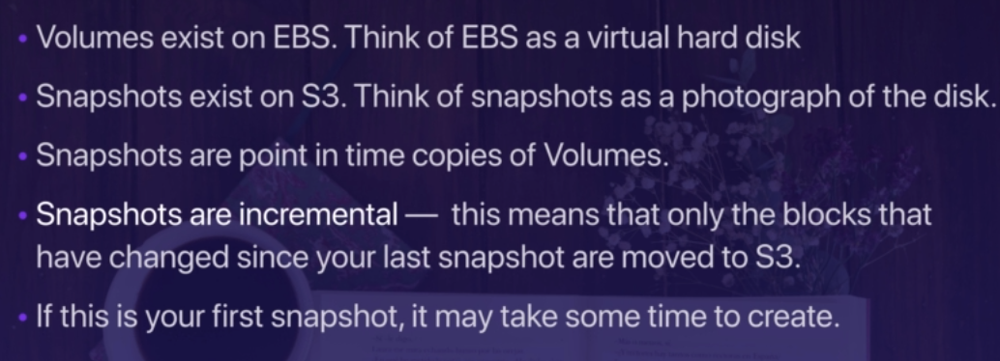

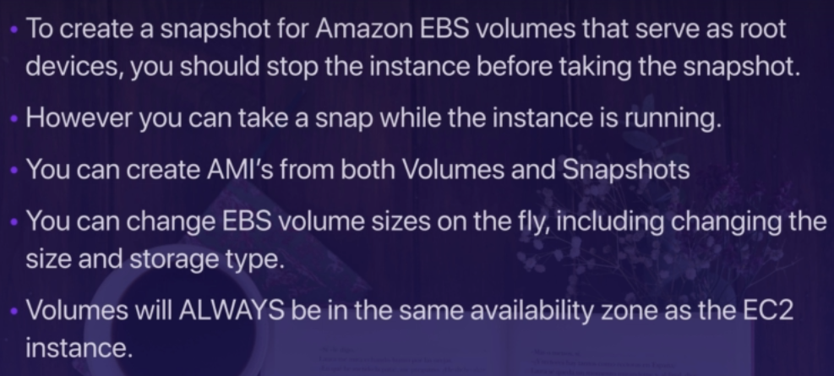

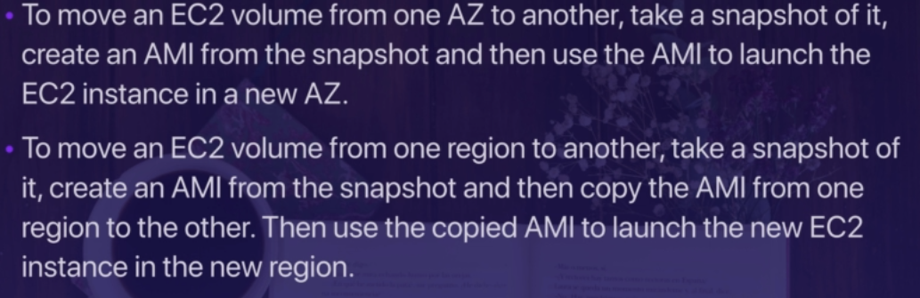

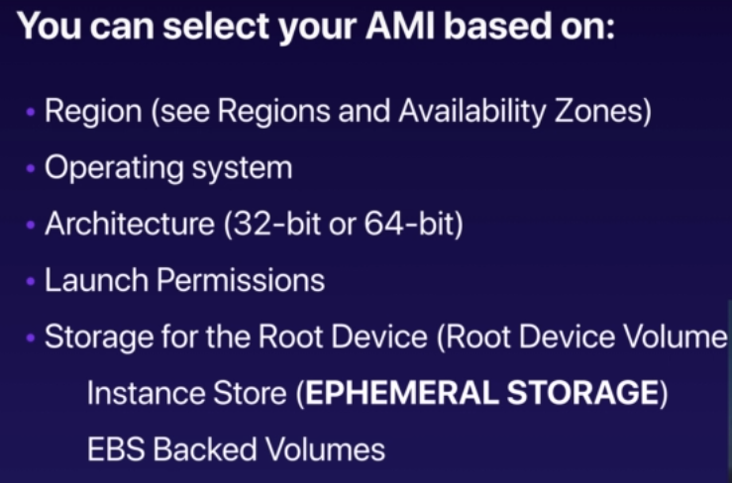

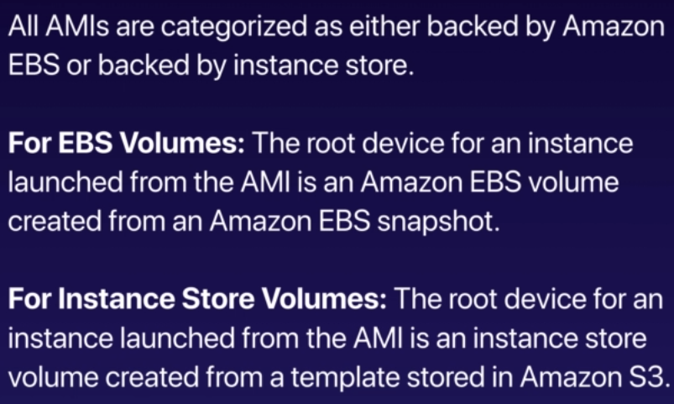

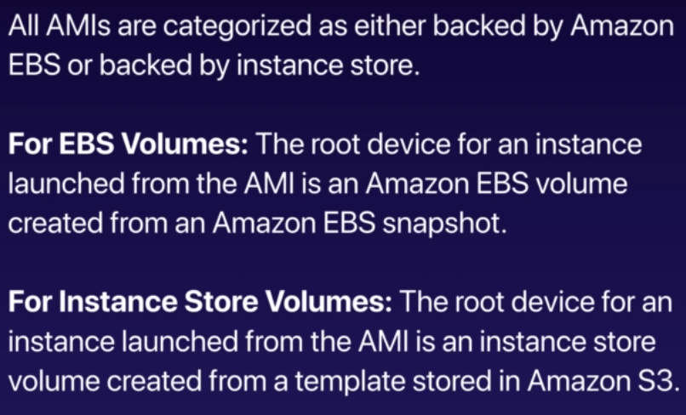

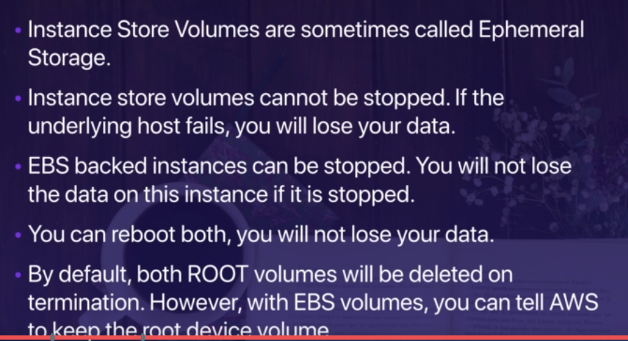

Ephemeral – temporary

We can choose instance store volume AMI from community AMIs

When you launch an instance, the **root** device **volume** contains the image used to boot the instance. When we introduced Amazon **EC2**, all AMIs were backed by Amazon **EC2** instance store, which means the **root** device for an instance launched from the AMI is an instance store **volume** created from a template stored in Amazon S3.

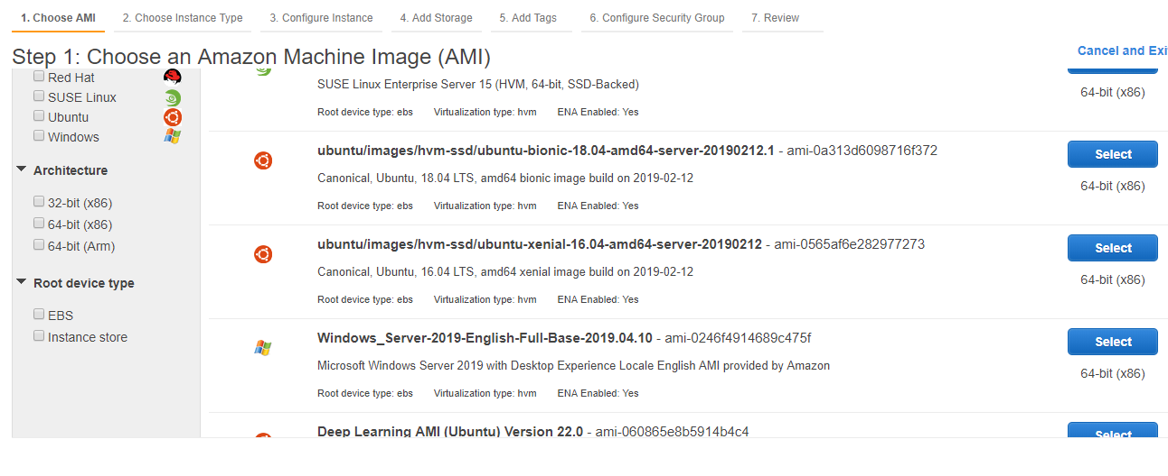

[Some Amazon Elastic Compute Cloud (Amazon EC2) instance types](https://aws.amazon.com/ec2/instance-types/) come with a form of directly attached, block-device storage known as the [instance store](https://docs.aws.amazon.com/AWSEC2/latest/UserGuide/InstanceStorage.html). The instance store is ideal for temporary storage, because the data stored in instance store volumes is not persistent through instance stops, terminations, or hardware failures.

For data you want to retain longer, or if you want to encrypt the data, use [Amazon Elastic Block Store (Amazon EBS) volumes](https://docs.aws.amazon.com/AWSEC2/latest/UserGuide/AmazonEBS.html) instead. EBS volumes preserve their data through instance stops and terminations, can be easily backed up with EBS snapshots, can be removed from one instance and reattached to another, and support full-volume encryption.

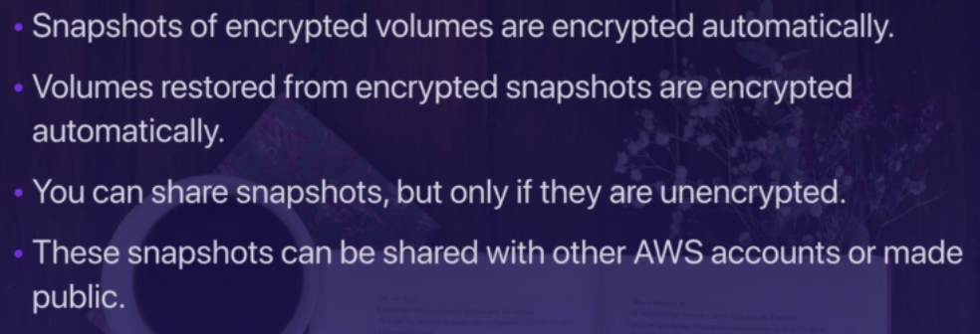

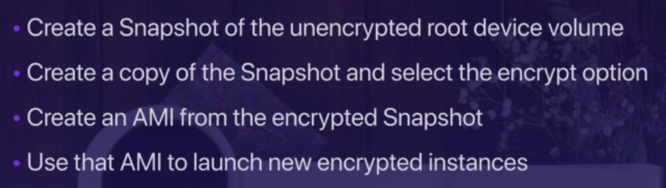

Cloudwatch:

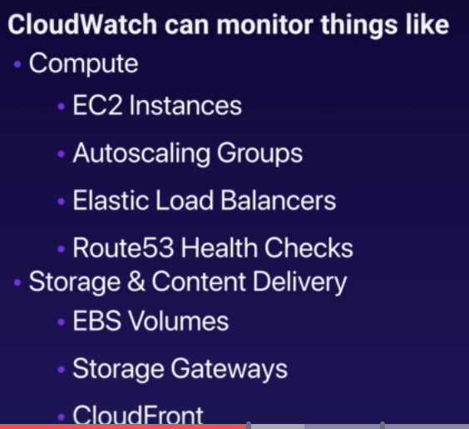

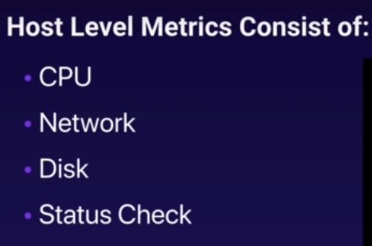

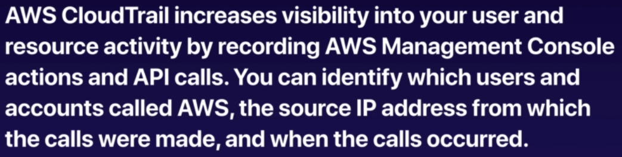

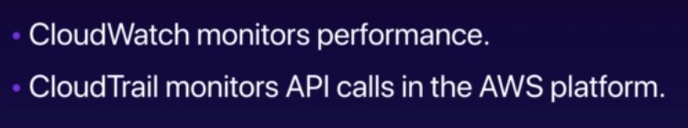

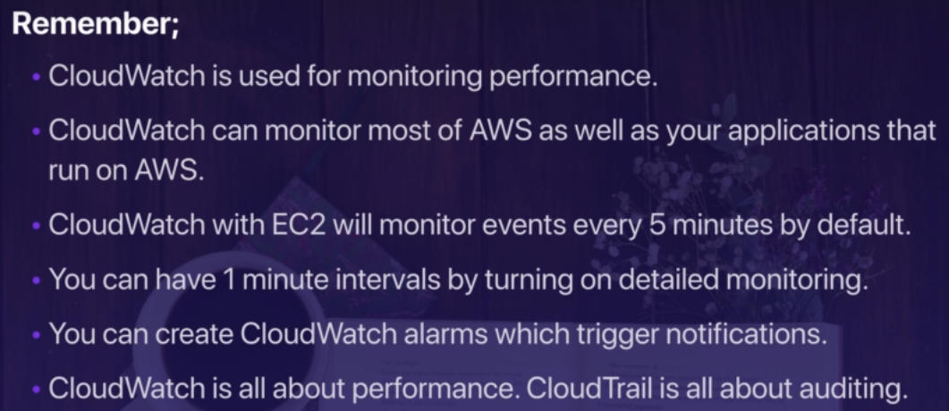

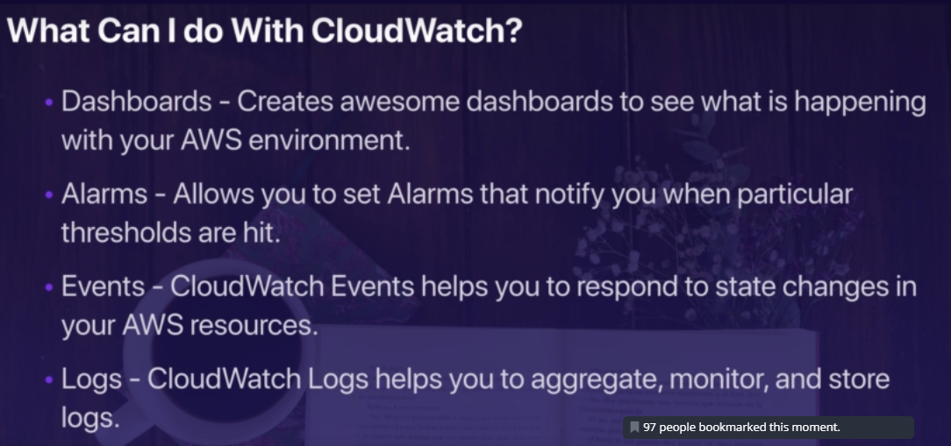

We have to create monitoring alert in cloudwatch.

For logs, an agent should be installed on eC2 instances

For events, the target could be queue etc